**Model Deployment**

**Task 1:** Saving trained model as .pkl

* Install joblib that will help us to save our model as .pkl

pip install joblib

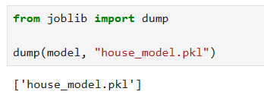

**Task 2:** Using Gradio Library that provide GUI

* Install Gradio Library

pip install gradio

Then the interface was looks like that Insert Values to be predicted

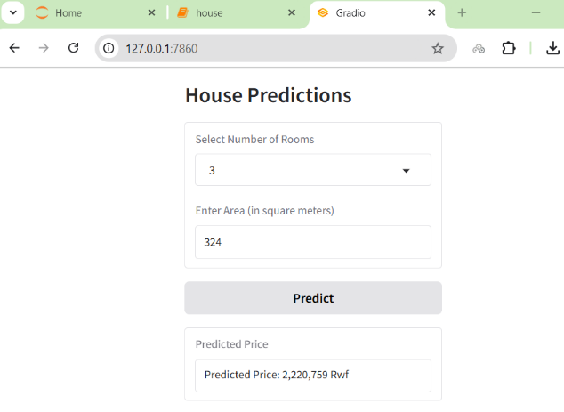

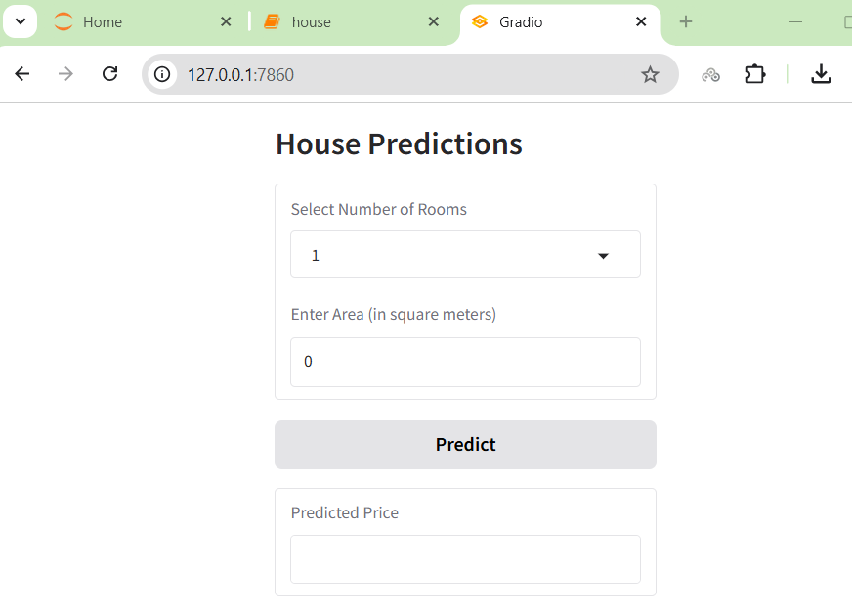

**Task 3:** Using APIs on Html

* We create two folders one named **API** and Other Named **Front_End** the API folder contain python file and model that will be used

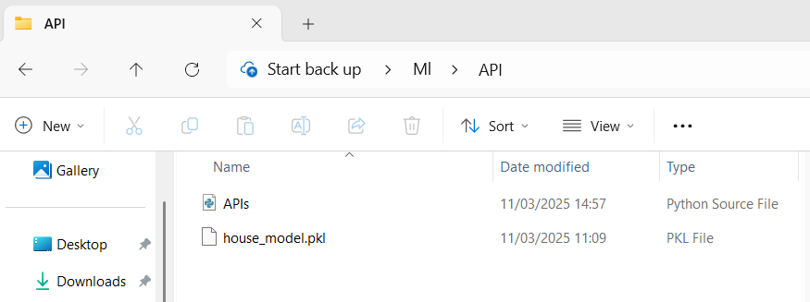

* We create one html file that will use API to use mode that, that file contain Java Script that will help us to run API this file is look like that

